St Mary’s RE Journey (Understanding Christianity) - Progressions
Refer to the Statement of Entitlement for Church of England Schools

Conceptual ‘Building Blocks’ | Making sense of the text (Theology) | Understanding  the impact  (Sociology) | Making connections  (Philosophy)
The core concepts are revisited as pupils move through school - God, incarnation, salvation, Gospel, creation. | Developing skills of reading and interpretation; understanding how Christians interpret, handle and  use biblical texts; making sense of meanings of texts for Christians. | Examining ways in which Christians respond to biblical texts and teachings, and how they put their beliefs into action in diverse ways within the Christian community and in the world. | Evaluating, reflecting on and  connecting the texts and concepts studied, and discerning possible connections between these and pupils’ own lives and ways of understanding the world.

Progression of Knowledge and vocabulary

Strand | Reception | KS1 | Lower KS2 | Upper KS2
God   | By the end of EYFS the children will…  See CREATION | Pupils will know that:  - Christians believe in God, and that they find out about God in the Bible.  - Christians believe God is loving, kind, fair and also Lord and King; and there are some stories that show this.  - Christians worship God and try to live in ways that please him. | Pupils will know that:  - Christians believe God is Trinity: Father, Son and Holy Spirit (see Incarnation).  - Jesus the Son is seen by Christians as revealing what God the Father is like. They believe he promises to stay with them and Bible stories show how God keeps his promises.  - Christians find that understanding God is challenging; people spend their whole lives learning more and more about God.  - Christians really want to try to understand God better and so try to describe God using symbols, similes and metaphors, in song, story, poems and art. | Pupils will know that:  - Christians believe God is omnipotent, omniscient and eternal, and that this means God is worth worshipping.  - Christians believe God is both holy and loving, and Christians have to balance ideas of God being angered by sin and injustice (see Fall) but also being loving, forgiving, and full of grace.  - Christians believe God loves people so much that Jesus was born, lived, was crucified and rose again to show God’s love.  - Christians do not all agree about what God is like, but try to follow his path, as they see it in the Bible or through Church teaching.  - Christians believe getting to know God is like getting to know a person rather than learning information.
Vocabulary
Creation and Fall  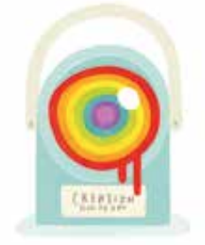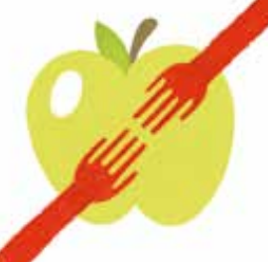 | Children will know that:  - The word God is a name.  - Christians believe God is Creator of the universe.  - Christians believe God made our wonderful world and so we should look after it. | Children will know  that Christians  believe:  - God created the universe, The Earth and everything in it are  important to God.  - God has a unique relationship with human beings as their Creator and Sustainer.  - Humans should care for the world because it belongs to God. | Children will know that Christians believe:  - God the Creator cares for the creation, including human beings.  - As human beings are part of God’s good creation, they do best when they listen to God.  - The Bible tells a story (in Genesis 3) about how humans spoiled their friendship with God (sometimes called ‘the Fall’).  - This means that humans cannot get close to God without God’s help.  - The Bible shows that God wants to help people to be close to him — he keeps his relationship with them, gives them guidelines on good ways to live (such as the Ten Commandments), and offers forgiveness even when they keep on falling short.  - Christians show that they want to be close to God too, through obedience and worship, which includes saying sorry for falling short. | Children will know that:  - There is much debate and some controversy around the relationship between the accounts of creation in Genesis and contemporary scientific accounts.  - These debates and controversies relate to the purpose and interpretation of the texts. For example, does reading Genesis as a poetic account conflict with scientific accounts?  - There are many scientists throughout history and now who are Christians.  - The discoveries of science make Christians wonder even more about the power and majesty of the Creator
Incarnation  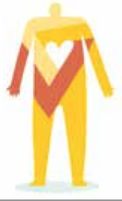 | Children will know that:  - Christians believe God came to Earth in human form as Jesus.  - Christians believe Jesus came to show that all people are precious and special to God. | Children will know that:  - Christians believe that Jesus is God and that he was born as a baby in Bethlehem.  - The Bible points out that his birth showed that he was extraordinary (for example, he is worshipped as a king, in Matthew) and that he came to bring good news (for example, to the poor, in Luke).  - Christians celebrate Jesus’ birth, and Advent for Christians is a time for getting ready for Jesus’ coming. | Children will know that:  - Christians believe Jesus is one of the three persons of the Trinity: God the Father, God the Son and God the Holy Spirit.  - Christians believe the Father creates; he sends the Son who saves his people; the Son sends the Holy Spirit to his followers.  - Christians worship God as Trinity. It is a huge idea to grasp, and Christians have created art to help to express this belief.  - Christians believe the Holy Spirit is God’s power at work in the world and in their lives today, enabling them to follow Jesus. | Children will know that:  - Jesus was Jewish.  - Christians believe Jesus is God in the flesh.  - They believe that his birth, life, death and resurrection were part of a longer plan by God to restore the relationship between humans and God.  - The Old Testament talks about a ‘rescuer’ or ‘anointed one’ — a messiah. Some texts talk about what this ‘messiah’ would be like.  - Christians believe that Jesus fulfilled these expectations, and that he is the Messiah. (Jewish people do not think Jesus is the Messiah.)  - Christians see Jesus as their Saviour (see Salvation).
Gospel  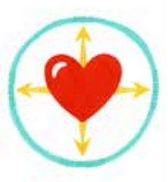 |  | Children will know that:  - Christians believe Jesus brings good news for all people.  - For Christians, this good news includes being loved by God, and being forgiven for bad things.  - Christians believe Jesus is a friend to the poor and friendless.  - Christians believe Jesus’ teachings make people think hard about how to live and show them the right way. | Children will know that:  - Christians believe Jesus challenges everyone about how to live — he sets the example for loving God and your neighbour, putting others first.  - Christians believe Jesus challenges people who pretend to be good (hypocrisy) and shows love and forgiveness to unlikely people.  - Christians believe Jesus’ life shows what it means to love God (his Father) and love your neighbour.  - Christians try to be like Jesus — they want to know him better and better.  - Christians try to put his teaching and example into practice in lots of ways, from church worship to social justice. | Children will know that:  - Christians believe the good news is not just about setting an example for good behaviour and challenging bad behaviour: it is that Jesus offers a way to heal the damage done by human sin.  - Christians see that Jesus’ teachings and example cut across expectations — the Sermon on the Mount is an example of this, where Jesus’ values favour serving the weak and vulnerable, not making people comfortable.  - Christians believe that Jesus’ good news not only transforms lives now, but also points toward a restored, transformed life in the future. (See Salvation and Kingdom of God).  - Christians believe that they should bring this good news to life in the world in different ways, within their church family, in their personal lives, with family, with their neighbours, in the local, national and global community.
Salvation   | Children will know that:  - Christians remember Jesus’ last week at Easter.  - Jesus’ name means ‘He saves’.  - Christians believe Jesus came to show God’s love.  - Christians try to show love to others. | Children will know that:  - Easter is very important in the ‘big story’ of the Bible. Jesus showed that he was willing to forgive all people, even for putting him on the cross.  - Christians believe Jesus builds a bridge between God and humans.  - Christians believe Jesus rose from the dead, giving people hope of a new life. | Children will know that:  - Christians see Holy Week as the culmination of Jesus’ earthly life, leading to his death and resurrection.  - The various events of Holy Week, such as the Last Supper, were important in showing the disciples what Jesus came to earth to do.  - Christians today trust that Jesus really did rise from the dead, and so is still alive today.  - Christians remember and celebrate Jesus’ last week, death and resurrection. | Children will know that:  - Christians read the ‘big story’ of the Bible as pointing out the need for God to save people. This salvation includes the ongoing restoration of humans’ relationship with God.  - The Gospels give accounts of Jesus’ death and resurrection.  - The New Testament says that Jesus’ death was somehow ‘for us’.  - Christians interpret this in a variety of ways: for example, as a sacrifice for sin; as a victory over sin, death and the devil; paying the punishment as a substitute for everyone’s sins; rescuing the lost and leading them to God; leading from darkness to light, from slavery to freedom.  - Christians remember Jesus’ sacrifice through the service of Holy Communion (also called the Lord’s Supper, the Eucharist or the Mass).  - Belief in Jesus’ resurrection confirms to Christians that Jesus is the incarnate Son of God, but also that death is not the end.  - This belief gives Christians hope for life with God, starting now and continuing in a new life (heaven).  - Christians believe that Jesus calls them to sacrifice their own needs to the needs of others, and some are prepared to die for others and for their faith.

Progression of Skills

Strand | Reception | KS1 | Lower KS2 | Upper KS2
Making sense of the text |  | By the end of KS1 the children will…  - Recognise that God, Creation, Incarnation and Salvation are part of a ‘big story’ of the Bible.  - Identify at least two different types of texts from the Bible; for example, a story, a parable, a gospel account of Jesus’ life, and instructions about how to behave.  - Tell stories from the Bible and recognise a link with a concept; for example, Creation, Incarnation, Gospel and Salvation.  - Give clear, simple accounts of what the texts mean to Christians. | By the end of lower KS2 the children will…  - Order at least five key concepts within a timeline of the Bible’s ‘big story’.  - List two distinguishing features of at least three different types of biblical text; for example, Gospel, parable, letter.  - Make clear links between biblical texts and the key concepts studied.  - Offer suggestions about what texts might mean and give examples of what the texts studied mean to some Christians. | By the end of KS2 the children will…  - Outline the timeline of the ‘big story’ of the Bible, explaining the place within it of the core concepts studied.  - Identify at least five different types of biblical texts, using technical terms accurately.  - Explain connections between biblical texts and the key concepts studied, using theological terms.  - Taking account of the context(s), suggest meanings for biblical texts studied, and compare their ideas with ways in which Christians interpret biblical texts, showing awareness of different interpretations.
Understanding  the impact |  | - Give at least three examples of ways in which Christians use Bible concepts, stories and texts to guide their beliefs, in their individual lives and in their church communities.  - Give at least three examples of how Christians put their beliefs into practice in church worship. | - Make simple links between Bible texts and concepts studied and how Christians live in their whole lives and in their church communities.  - Describe how Christians show their beliefs in worship and in the way they live. | - Make clear connections between Bible texts and concepts studied with what Christians believe, how Christians worship and how Christians behave in their whole lives, their church communities, and in the wider world.  - Show how Christians put their beliefs into practice in different ways; for example, in different denominations.
Making connections |  | - Think, talk and ask questions about whether the text has something to say to them, exploring different ideas. | - Raise questions and suggest answers about how far the big ideas explored in the Bible and the concepts studied might make a difference to how pupils think and live.  - Make links between some of the stories and teachings in the Bible and life in the world today, expressing some ideas of their own clearly | - Identify ideas arising from their study of texts and concepts, and comment on how far these are helpful or inspiring, justifying their responses.  - Weigh up how biblical ideas, teachings or beliefs relate to the issues, problems and opportunities of their own lives and the world today, developing insights of their own.

EYFS concepts and knowledge:
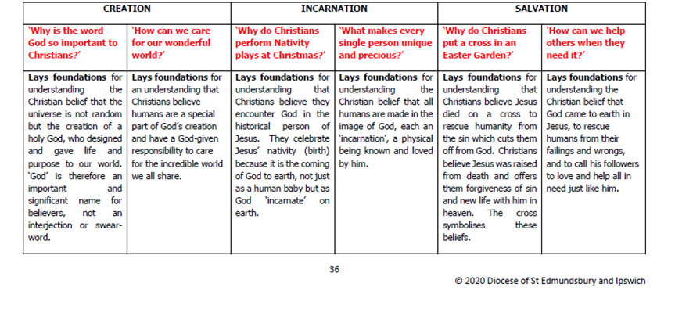

Progression of Jewish knowledge of text - practice - living
End of KS1
Pupils will be able to:
Text | Know that Jewish stories contain examples of good deeds  Remember all, or parts of, the story of Ruth  Say at the end of the creation story God rested.  Remember that the Torah is the most important book for Jewish people given by God. It was written down by a great leader called Moses.  Recall some of the stories of Moses e.g. 10 commandments or his birth
Community | Know that Jewish people welcome babies into their community.  Know that Jewish families have a day of rest every week.  That at the start of Shabbat, a special meal, candles are lit and blessings said.  Say that the Torah is kept in a synagogue or in a special ark.  Know the Torah contains rules.
Living | Know that Jewish people care for their world.  Describe what some Jewish people wear when they pray.  Remember that a mezuzah contains important words for Jewish people (the Shema).  Demonstrate how a mezuzah is used by Jewish people.

Progression of Hindu knowledge of text - practice - living
End of KS2
Pupils will be able to:
Text | Begin to describe what Hindus might learn from one of the stories of the Panchatantra about living the right way.  Describe what a Hindu might learn from the story of Rama and Sita.  Understand that some Hindus read from the Gita every day for guidance, comfort and advice.
Community | Describe some things Hindus do to celebrate Rama and Sita’s commitment to duty and describe how Hindus celebrate Diwali.  Explain that Hindus are encouraged to perform acts of selfless kindness.  Express the important role of devotion for those who follow the Bhakti pathway.
Living | Know that even Hindu children must learn to take responsibility for gathering good karma.  Give examples of how Hindus express beliefs and feelings about Krishna.  Make links between their own and Hindu spiritual pathways

Progression of Muslim knowledge of text - practice - living
 | End of KS1  Pupils will be able to: | End of KS2  Pupils will be able to:
Text | Recognise that the names ‘Allah’ and ‘Muhammad’ are important to Muslims.  Suggest why the words of the Bismillah are important to Muslims.  Tell a story about Muhammad and say what it teaches a Muslim about compassion.  Recall some different names of Allah e.g. the doer of good, the generous, which show what a Muslim believes about God. | Explain that Muslims respond to the call for prayer.  Describe what a Muslim might learn from the story of Bilal and the first call to prayer.  Describe Muslim belief in one God, the most important being in the universe, who they believe they should obey in every way. He is Allahu Akbar or ‘God most great’  Describe ways Muslims show respect towards the Qur’an and give reasons for this.  Retell the story of how the Qur’an was revealed to Muhammad.  Explain how the Kaaba or ‘cube’ reminds Muslims that there is only one God.
Community | Use the words ‘fasting’ and ‘sharing’ to talk about what Muslims do during Ramadan. | Describe some things Muslims do when they get ready for prayer and how the physical actions show submission to Allah.  Know that a mosque in a Muslim place of worship.  Describe some practices and experiences of Muslim children at a madrassah.  Describe why only some Muslims seek to become Hafiz and how the study affects both their lives and the lives of others.  Recall the Five Pillars of Islam and how the practice of each pillar makes a Muslim feel they belong to the ‘ummah.’
Living | Recall how Muslims prepare for and celebrate Eid-ul-Fitr. | Explain that saying the Bismillah reminds Muslims that Allah is involved in everything.  Show how Muslims express the idea of revelation as a rope reaching down to earth, suggesting what the image means.  Make links that show how Muslim belief and practices come from the teachings of the Qur’an or from the Sunnah of the Prophet.  Explain some key Muslim teachings about Tawheed or the one-ness of Allah.  Describe the impact of Hajj on a Muslim.

