Communication and Language  Listening:  Listen and understand instructions while busy with another task.  Attention:  Maintain activity while listening.  Respond:  Describe events in some detail.  Understanding:  Understand how, why, where questions.  Speaking:  Begin to ask ‘I wonder…’  Express ideas about feelings and experiences.  Articulate their ideas and thoughts in well-formed sentences.  Use language to reason.  Use talk to help work out problems and organise thinking and activities.  Ongoing  Learn new vocabulary Use new vocabulary in different contexts.  Use new vocabulary through the day in discussions and conversations.  Learn new rhymes, poems, and songs.  Listen to and talk about stories to build familiarity  and understanding. |  | Personal, Social and Emotional Development  PSHE SCARF: Being My Best  Covering: Feeling resilient and confident in their learning. Name and discuss different types of feelings and emotions. Learn and use strategies or skills in approaching challenges. Understand they can make healthy choices. Name and recognise how healthy choices can keep us well.  Feel it emotions: Pleased, worried  School value: Perseverance  Express feelings:  Beginning to know that children think and respond in different ways to them.  Manage behaviour:  Use language to negotiate, play and organise.  Self-awareness:  Confident to try new activities  Can talk about their own abilities positively.  Independence:  Can get dressed and undressed for nature school/ PE club sessions.  Begin to show persistence when faced with challenges.  Collaboration:  Show resilience and perseverance.  Can keep play going by co-operating, listening, speaking, and explaining.  Can reflect on the work of others and self-evaluate their own work.  Social skills:  Friendship - Knowing what makes a good friend. |  | Physical Development  Complete PE: Ball skills: rackets, bats and balls  Combine different movements with ease and fluency  Develop the foundations of a handwriting style which is fast, accurate and efficient.  Further develop and refine a range of ball skills including throwing, catching, kicking, passing, batting, and aiming.  Know and talk about the different factors that  support overall health and wellbeing: regular  physical activity and healthy food choices.  Develop the overall body strength, co-ordination, balance, and agility needed to engage successfully with future physical education sessions and other physical disciplines including dance, gymnastics, sport, and swimming.  Develop their small motor skills so that they can use a range of tools competently, safely, and confidently. Suggested tools: pencils for drawing and writing, paintbrushes, scissors, knives, forks, and spoon.  Use their core muscle strength to achieve a good posture when sitting at a table or sitting on the floor.  Develop overall body-strength, balance, co-ordination, and agility.
Literacy  COMPREHENSION  Begin to create their own stories verbally and include key story telling vocab (once upon a time, One …. Day,)  Help class puppet to create their own stories.  Play influenced by experience of books  To explain why they like a character or story (E), to find a word which means…. (V)  Emergent writing: Continue to build on knowledge of letter sounds to build words in writing. Use writing in play. Use familiar words in their writing.  Composition: Write a simple sentence with a full stop. Use conjunctions.  Spelling: Spell words by drawing on knowledge of known grapheme correspondences.  Make phonetically plausible attempts when writing more complex unknown words.  Spell CEW’s with increasing accuracy (Phase 2 and 3)  Handwriting: Form most lower-case letters correctly, starting and finishing in the right place, going the right way round and correctly orientated. Include spaces between words.  Helicopter stories progression:  Begin to write their own short stories – using sotry map to support  Opportunities to demonstrate writing skills – Story maps, labels and captions for life cycles, lists. |  |  | Reception Class Summer 1 Learning Journey  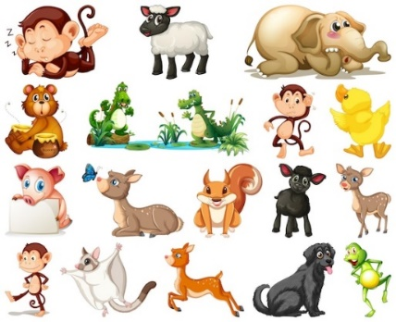  Fur, Feathers and Feet | Mathematics  Continue learning from last half term: Week 18-20  Pupils will consolidate their counting skills, counting to larger numbers and developing a wider range of counting strategies. They will secure knowledge of number facts through varied practice.  Pupils will:  • continue to develop their counting skills, counting larger sets as well as counting actions and sounds  • explore a range of representations of numbers, including the 10-frame, and see how doubles can be arranged in a 10-frame • compare quantities and numbers, including sets of objects which have different attributes  • continue to develop a sense of magnitude, e.g. knowing that 8 is quite a lot more than 2, but 4 is only a little bit more than 2  begin to generalise about ‘one more than’ and ‘one less than’ numbers within 10  • continue to identify when sets can be subitised and when counting is necessary  • develop conceptual subitising skills including when using a rekenrek  Compare mass (2)  Spatial reasoning (1)  Spatial reasoning (2)
Phonics:  Phase 4  Continue to revisit Phase 3: ch, sh, th, ng, ai ee igh oa oo oo ar or ur ow oiear air ure er  CEW’s: Phase 4 | Understanding the World  Draw information from a simple map such as identifying land and water on a map or globe.  Make observations of the environment around them drawing pictures of animals and plants  Recognise and discuss how environments in stories and images are different to the environment they live in.  Explain some similarities and differences between life in this country and life in other countries.  Beginning to look at and talk about maps (real or imaginary) in stories, non-fiction books, atlases and on globes.  Recognising that some stories are set a long time ago and using stories and non-fiction books to find out about life in the past.  Recognising significant dates for them (birthday).  Develop an understanding about growth, decay and changes over time e.g. using the garden allotment when planting, visiting secret garden planting projects  Understand the effect of changing seasons on the natural world around them  Make simple records of what I notice or how things change (WS)  Know some similarities and differences between the natural world around them and contrasting environments, drawing on their experiences and what has been read in class (WS)  Can create content such as a photo or video recording  Logs on to busy things using password  RE- How Can We Care For Our Wonderful World? (EP) |  |  |  | Expressive Arts and Design  Create collaboratively sharing ideas, resources, and skills  Combining different media and skills- Modroc/paper mache (giant nest)  Exploration of natural resources for art - Rubbings of leaves and plants.  Summer 1 Artist Study: Emily Stackhouse– oil pastels  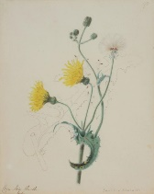  Fernand Leger (summer 2 Fathers day)

